1) If you have PowerPoint Microsoft 365, PowerPoint 2016, 2019 or PowerPoint 2013 click the following link for the instructions: https://support.office.com/en-us/article/turn-your-presentation-into-a-video-c140551f-cb37-4818-b5d4-3e30815c3e83

2) If you have PowerPoint 2007 or 2008 please see page 4

If you have PowerPoint 2010:
Turn your presentation into a video
After you've created your slides and recorded any timing and narrations and laser pointer gestures that you want to include, you're ready to create a video file.
- On the File menu, select Save to ensure all your recent work has been saved in PowerPoint presentation format (.pptx).
- Click File > Export > Create a Video. (Or, on the Recording tab of the ribbon, click Export to Video.)
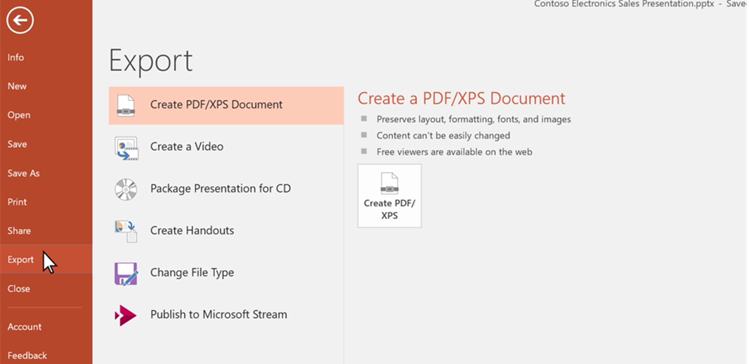
- In the first drop-down box under the Create a Video heading, select the video quality you want, which pertains to the resolution of the finished video. The higher the video quality, the larger the file size. (You may want to test them to determine which one meets your needs.)
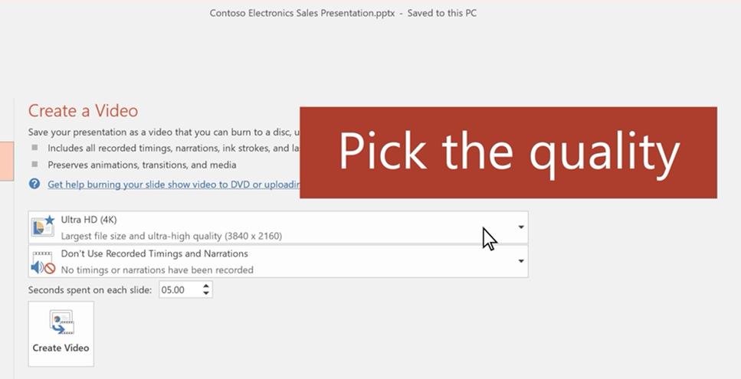
- The second drop-down box under the Create a Video heading tells whether your presentation includes narration and timings. (You may switch this setting if you like.)
  - If you haven't recorded timed narration, by default the value is Don't Use Recorded Timings and Narrations.
The default time spent on each slide is 5 seconds. You can change that timing in the Seconds to spend on each slide box. To the right of the box, click the up arrow to increase the duration, or click the down arrow to decrease the duration.
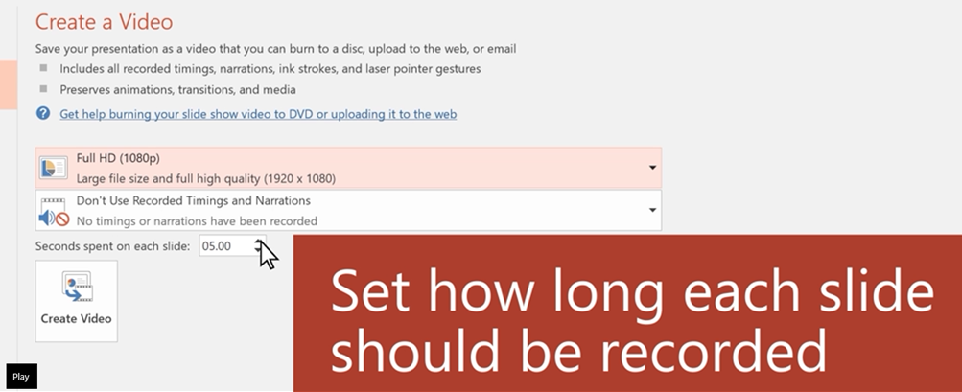
  - If you have recorded a timed narration, by default the value is Use Recorded Timings and Narrations.
- Click Create Video.
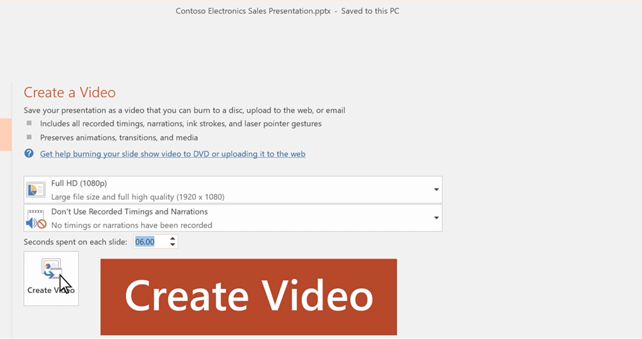
- In the File name box, enter a file name for the video, browse for the folder that will contain this file, and then click Save.
- In the Save as type box, choose either MPEG-4 Video or Windows Media Video.
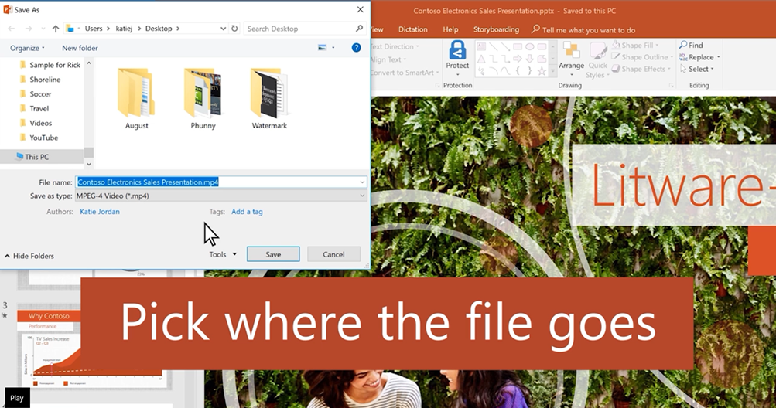
You can track the progress of the video creation by looking at the status bar at the bottom of your screen. The video creation process can take up to several hours depending on the length of the video and the complexity of the presentation.
- To play your newly-created video, go to the designated folder location, and then double-click the file.
If you have PowerPoint 2007 or 2008, you can use one of the programmes for screen recording.

You can download a free tool on https://www.freescreenrecording.com

1) Enter your email and click Download.

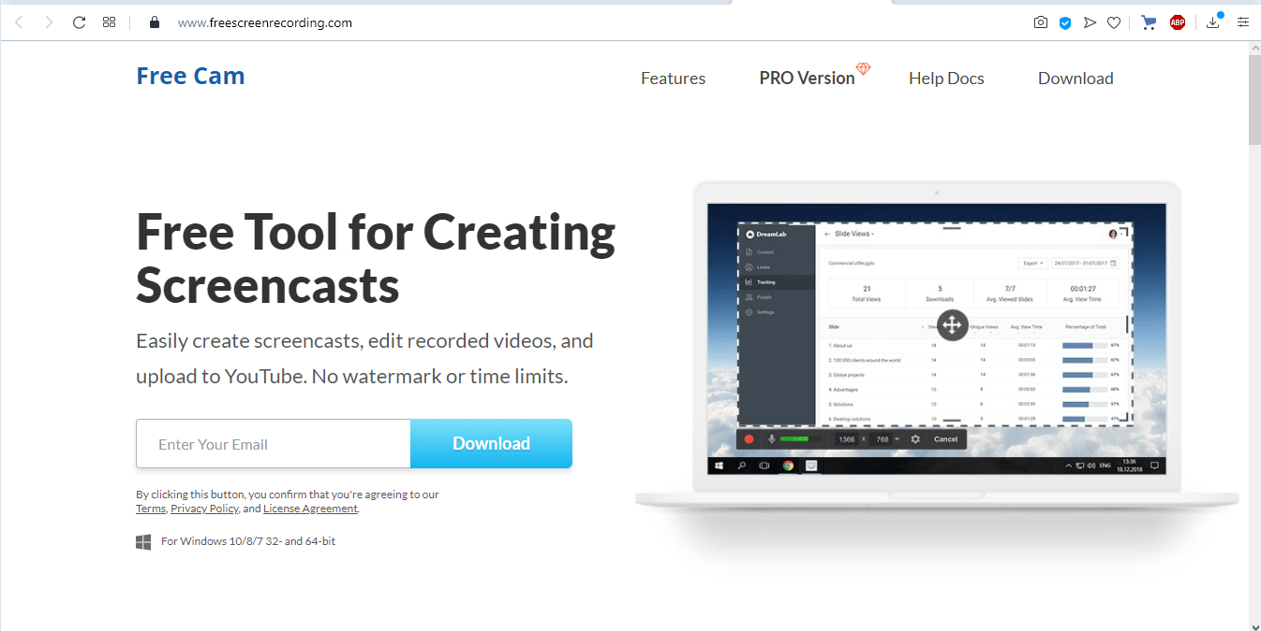

2) Your download should start automatically.

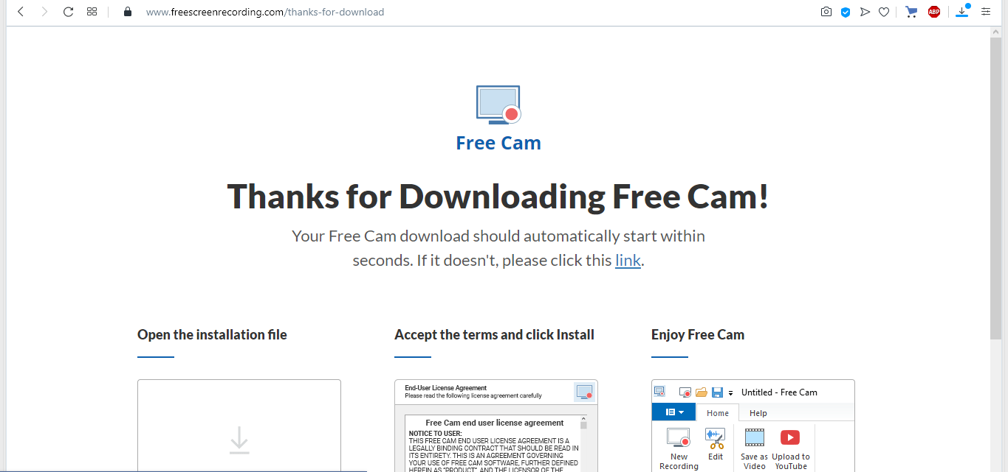

3) Install Free Cam.

4) Open the programme.

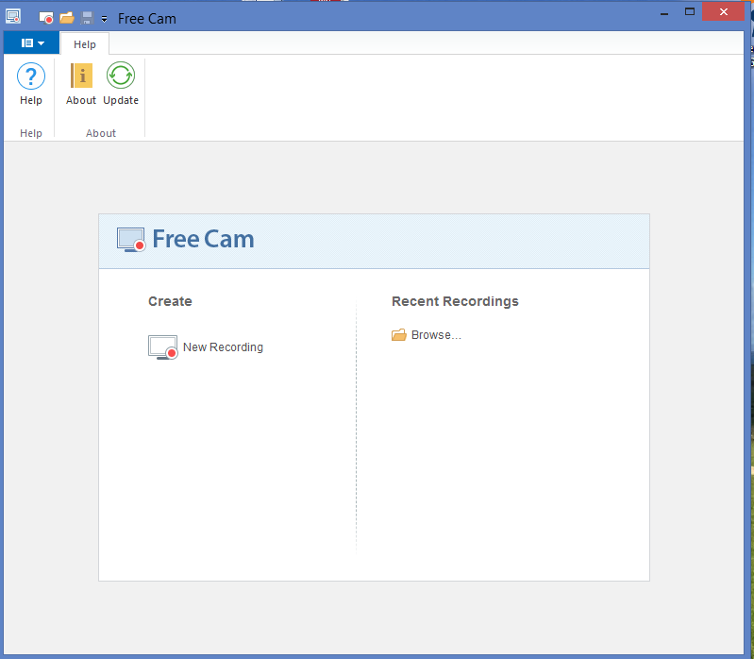

5) Open your PowerPoint presentation.

6) Click New Recording.

7) You can select a recording area and do not forget to unmute your microphone.

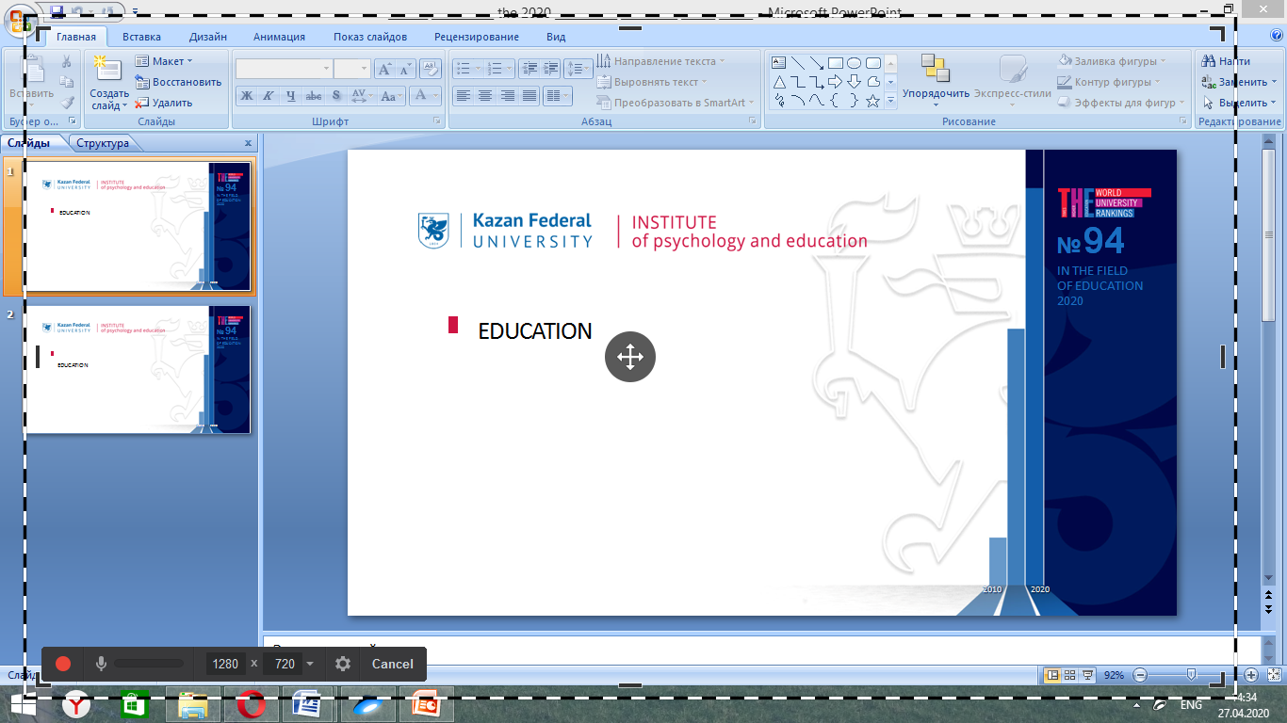

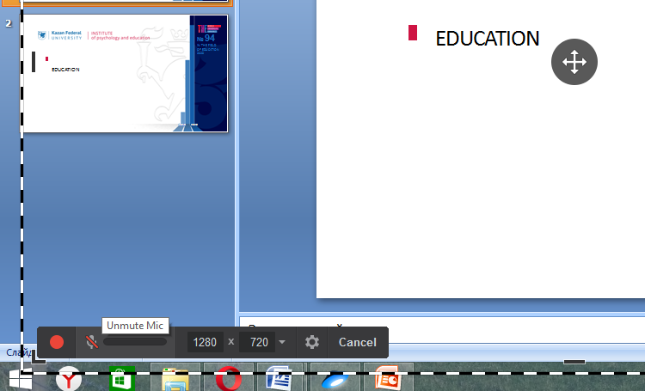

8) Start your sliding show and click the red button to record your voice over your first slide. Then continue with the next one.

9) When your PowerPoint presentation is finished stop recording by clicking Done on the Windows taskbar.

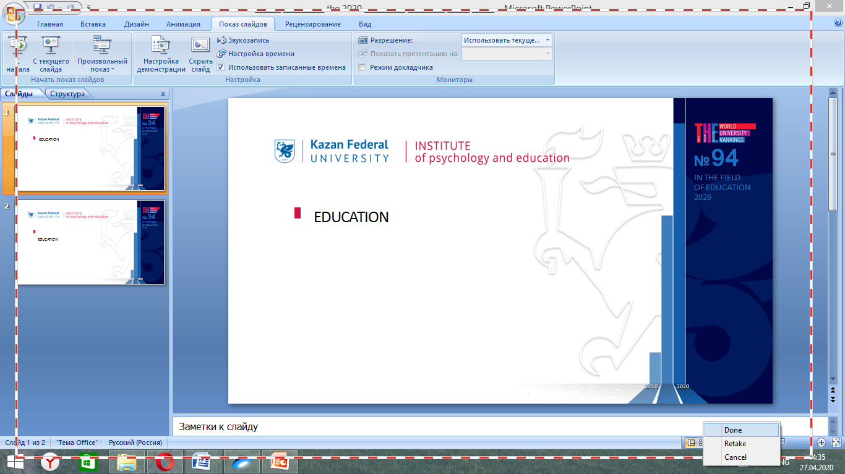

10) Free Cam will be automatically opened with your recording. You can play it and edit it if you wish.

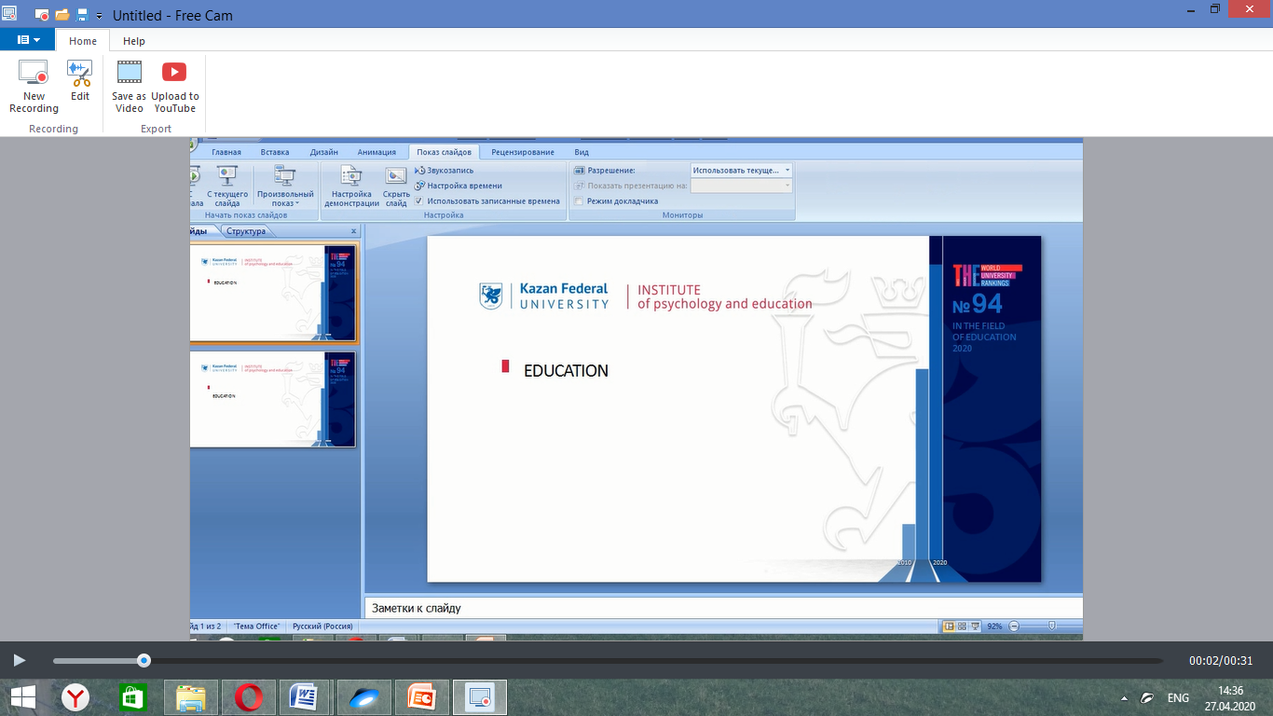

11) As a final step, you need to save your presentation as a video. Enjoy!
